Name Date
Stage 9 End of unit 14 test
1 The table shows information about three prisms. Fill in the missing values in this table.
Prism | Area of cross-section | Length of prism | Volume of prism
A | 9 cm2 | 12 cm | ____cm3
B | 12 mm2 | ____mm | 60 mm3
C | ____m2 | 8 m | 36 m3

[3]
2 Work out the volume of this prism.
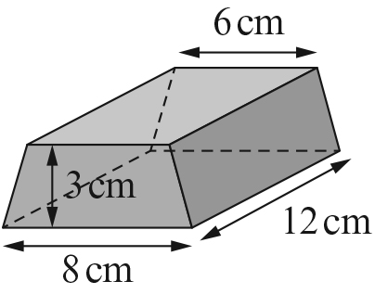

[2]

3 Work out the volume of this cylinder. Give your answer correct to 3 s.f.
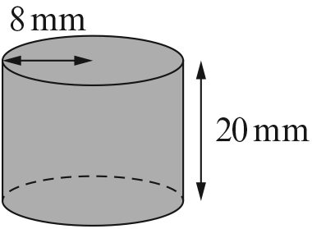

[2]

4 A cylinder has a radius of 2.5 cm and a volume of 78.54 cm².
Work out the height of the cylinder. Give your answer to the nearest centimetre.

[3]
5 A cylinder has a height of 35 mm and a volume of 15 834 mm³.
Work out the radius of the cylinder. Give your answer to the nearest millimetre.

[3]
6 The diagram shows a cylinder and a triangular prism.
Which shape has the greater surface area? Show your working.
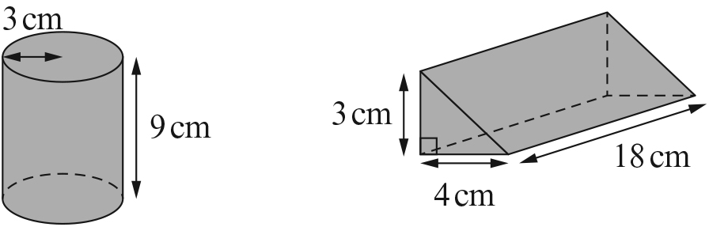

[8]

7 For each of these shapes
i write down the number of planes of symmetry
ii draw the planes of symmetry onto the shape.
a i planes of symmetry
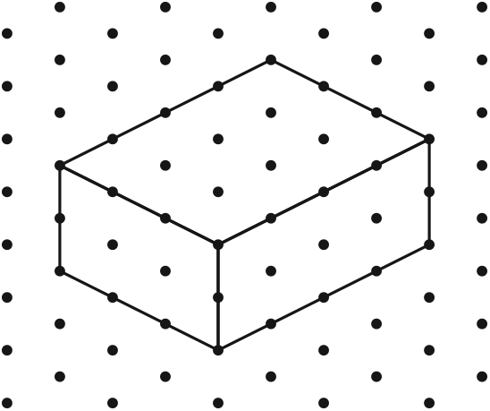
ii

b i planes of symmetry [2]
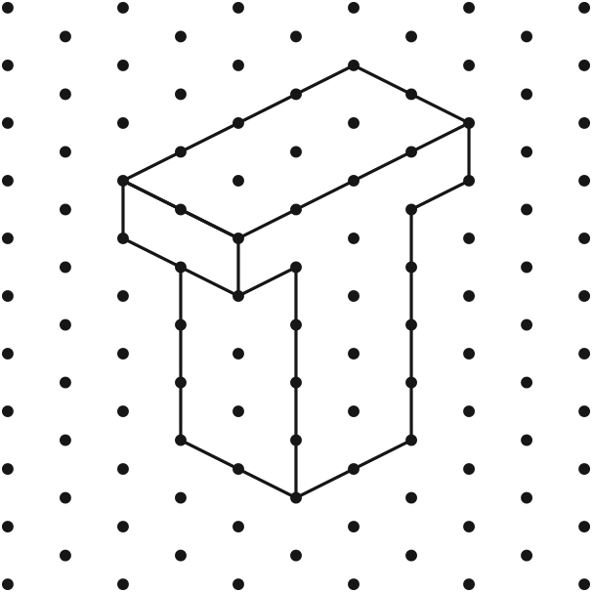
ii

[2]
[Total: 25 marks]

END OF TEST

